PUBLIC NOTICE OF CITY COUNCIL VACANCY

In accordance with Utah State Code Ann. 20A-1-510(b), notice is hereby given that the Santaquin City Council has a Council seat vacancy as of November 3, 2021 and will be accepting applications from interested individuals for filling said vacancy.

Applications for the City Council seat can be found at this link here. Completed applications, may include an optional cover letter and resume, and should be sent to City Recorder Aaron Shirley at ashirley@santaquin.org or delivered to the Santaquin City Offices, 275 West Main Street, Santaquin, Utah 84655 Questions may also be sent to the City Recorder via email listed above, by phone at 801-754-1904, or by appointment.

The deadline for application submission is November 19, 2021 at 1:00 p.m.

Candidates will be interviewed by the City Council in an open public meeting taking place on November 23, 2021 at 6:00 p.m. at the City Council Chambers located on the 2nd floor of City Hall at 275 West Main Street, Santaquin, UT 84655.

Certificate of Mailing and Posting

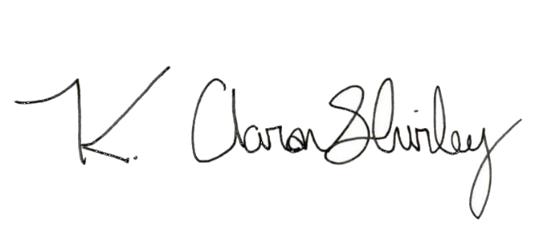
The undersigned duly appointed City Recorder for the municipality of Santaquin hereby certifies that a copy of the foregoing Notice was emailed to the Payson Chronicle. Notice was posted Utah Public Notice and the Santaquin City Website and Social Media pages.

By: ______________________________
K. Aaron Shirley, Recorder

